Towards a Proton CT Head Scanner

Motivation: Proton therapy requires the knowledge of the stopping power (SP) in the patient in order to place the Bragg peak in the tumor. However, the range errors in x-ray, CT registration (3%-5%) constitute a major source of uncertainty based on Hounsfield Unit (HU) - Relative Stopping Power (RSP) calibration curves. A proton CT (pCT) scanner would obviate this conversion discrepancy allowing a lower radiation dose and more accurate treatment.

Overview: While our Phase 1 pCT scanner (pCT1) [CITE] was designed for proof of concept, our Phase 2 pCT scanner (pCT2) was designed for clinical application. Since pCT1 has a data rate of 10 kHz, a scan took about 20 hrs [CITE]; however, pCT2 has a data rate of 1 MHz which will require about 10 min. To allow pCT2 to fit within a gantry, GEANT4 simulations [CITE] were used to optimize the geometry. Fig. 1 shows a 200 MeV proton beam entering the left of the scanner and passing through a cylindrical phantom before stopping in the the energy detector. IMPROVE PIC
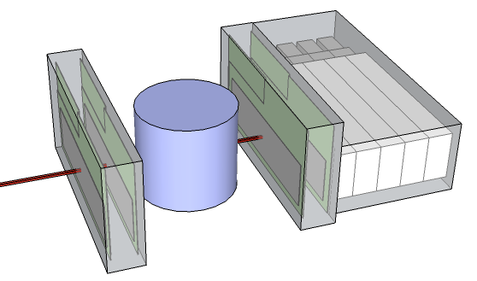
Fig. 1 pCT2

Hardware: The pCT scanner is made from two principle components: the position-detecting Tracker and Energy detector. The Tracker uses Silicon Strip Detectors (SSD) for their low noise and good efficiency [CITE]. Undesirable image artifacts in the pCT1 prompted us to adopt a slim-edge design allowing us to abut (rather than overlap) the 6” SSD [see Fig 1(b)] for pCT2. To accommodate the rapid readout of the SSD electrons at 1 MHz, an Application Specific Integrated Circuit was designed. To avoid the resolution-reducing affects of Multiple Coulomb Scattering (MCS), the SSD were manufactured at 200 μm thickness; thus, each proton unavoidably passes through 1600 μm of silicon before entering the energy detector.
The energy detector was designed for speed and accuracy. To decrease response-time of the CsI crystals for pCT1, we used a polystyrene scintillator & photomultiplier. Range straggling, which amounts to 1% of the total path length, presents a constant error of 4 mm for 200 MeV protons. To improve range accuracy, we use a multistage calorimeter which gives a sequence of smaller, more-accurate measurements along stopping path of the proton.
Procedure: A successful pCT scan requires a sequence of events: calibration, data acquisition, data culling, hull detection, image reconstruction. Calibration relates the results of the photo-detector to a Water Equivalent Path Length (WEPL). Data acquisition from the Energy detector and ASICs is performed by a hierarchy of Field Programable Gate Arrays (FPGA) which transmit the results over gigabit ethernet to computer. Then the data is partitioned into bad (partial track information) and good events. The good events are used first for hull detection and later to generate Most Likely Path (MLP) statistics. Finally, the most likely paths are used to populate a matrix whose solution converts the WEPL of protons to the RSP of the subject.
Results: The latest experimental results, from a partially completed scanner, have established a data acquisition rate of over our 1 MHz target. During our first, fully-functional test, we will use phantoms to establish spatial and contrast resolution of the pCT2; however, we present results from pCT1. Fig. 2 shows 200 MeV energy-loss and scattering radiographs of a hand phantom generated using pCT1. While both radiographs displayed anatomical details of the hand phantom, the energy loss radiograph had a noticeably higher resolution. The estimated dose delivered to the center of the hand phantom during radiography was ~20μSv which is within the same order of magnitude as the dose delivered in the state of the art X-ray radiography for a hand or a foot. We expect better image quality from pCT2.
Conclusion: We demonstrate the promise of proton imaging (proton radiography and Proton CT) now within reach of becoming a new, potentially low dose clinical imaging modality.

